

How To Be Successful on Supervision

Getting Started
Report to a Probation Office as soon as you leave court or are released from jail.

Santa Cruz Probation Office Watsonville Probation Office
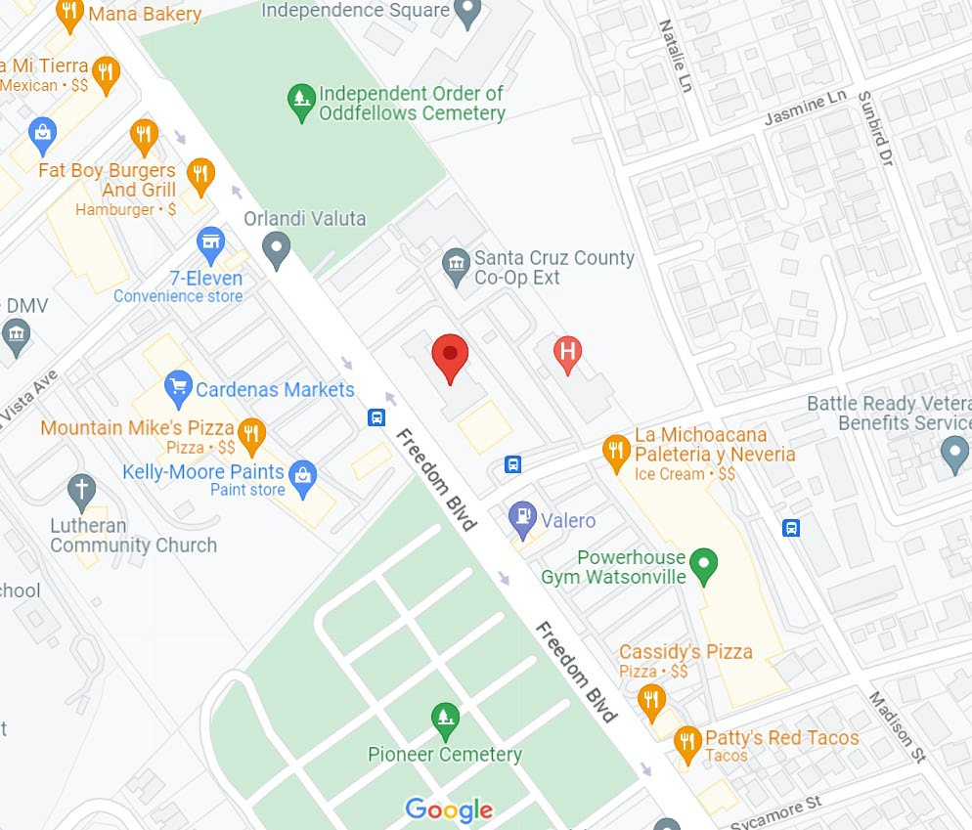
Monday – Friday, 8 AM – 12 PM & 1PM – 5PM Monday – Friday, 8 AM – 12 PM & 1PM – 5PM 303 Water Street, Suite 9 1430 Freedom Blvd., Rm# 14

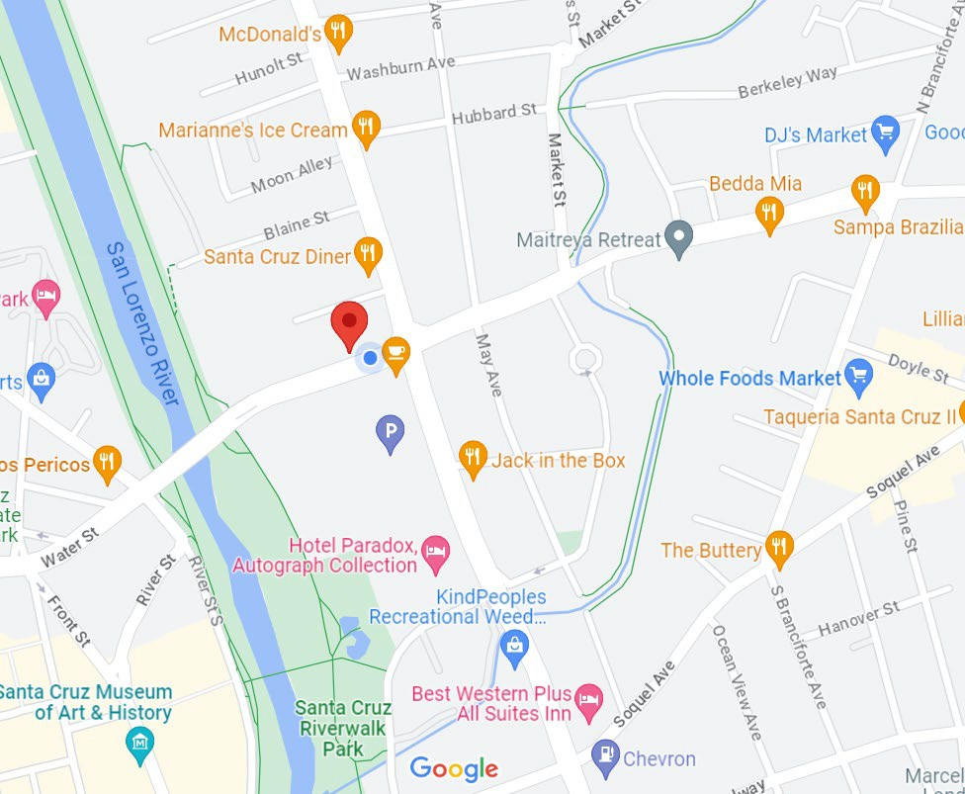
Santa Cruz, CA 95060 (831)454-2150
Watsonville, CA 95076
(831)763-8070

 STAY CONNECTED
If you are not able to report in person, you must contact the Probation Office by phone or using the following online resources:
https://www.co.santa-cruz.ca.us/Departments/ProbationDepartment/ContactUs.aspx).

If you do not have stable housing, you may provide an address and telephone number where you can be reached or where a message may be left (with a friend or family).

Any address or phone # change must be reported immediately.
Can I leave Santa Cruz County or move?
You MUST HAVE PERMISSION to leave the State for any length of time, and you will need a written Travel Permit from Probation. In some situations, you may need permission to leave the County (ex: if you are on PRCS supervision or have a registration requirement). If you want to move, you will also need to apply for a transfer (your Probation Officer can help you with that).
Always ask before you go!


Frequently Asked Questions Who is my Probation Officer?
Until you are assigned to a Probation Officer, you will be provided with a Supervisor’s name and phone number in case you have any questions. You can ALWAYS ask to speak with the Officer of the Day (the Officer of the Day is a designated probation staff in each office).

What do I do now?
Your Probation Officer will make program and resource referrals. They will also answer any questions you might have and review the terms / conditions you agreed to in court. Together you will make a plan for success!

Struggling?
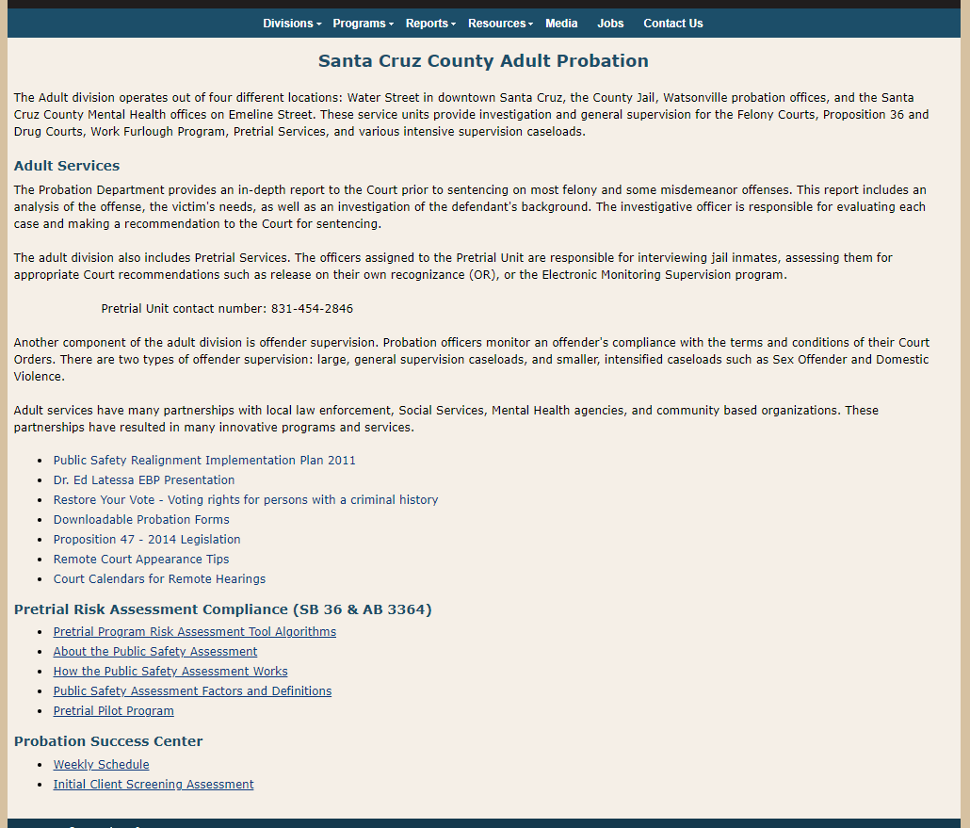
If you have questions or need help always reach out. We have many resources to support you during your time on supervision both at the Probation Success Centers and throughout the community. Scan the QR code below to view a video about our Probation Success Centers, or click on the link below to see a schedule of services:

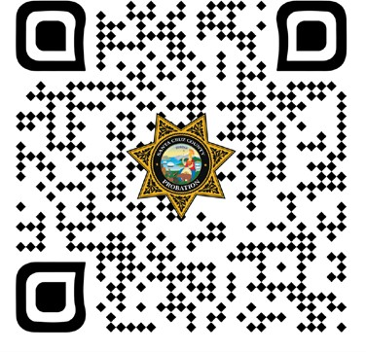

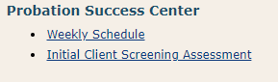
(Click this link or Image Above)
North County Probation Success Center
303 Water Street, Santa Cruz CA 95060 (831) 454-2250 Open: Monday – Friday, 9 AM – Noon & 1 PM – 4 PM
South County Success Center
2007 Freedom Blvd, Freedom CA 95019 Phone# 831-348-0081 Open: Monday – Friday, 9:00 AM – Noon & 1 PM to 4 PM
 Email is a great way to keep in touch!
If you do not have one, you can get help at the Probation Success Centers

What if I have contact with the police?
If you are arrested or cited for a new offense, or if you are stopped and searched, contact Probation within 24 hours (in person, by phone, by email). If your Probation Officer is unavailable, you may leave a voice mail message or speak with the Officer of the Day.


https://www.santacruzdefenders.us

Legal Questions?
If you do not know who your attorney is, ask to speak with the “Help Attorney” Call: 831-454-5300

